

CSA15 – CLOUD COMPUTING AND BIG DATA ANALYTICS

ASSIGNMENT 1 – CO1

Design, Analyse and Validate a Cloud-Based Solution for Migrating a Legacy University Management System

CO1: Apply cloud computing technologies including hardware–software evolution, virtualization, web services, and service models to develop cloud-based solutions.

Field | Details | Field | Details
Student Name | Devaganesh.S | Register Number | 1911260104
Department /  Section | B.Tech CSE | Academic Year / Semester | 2026-2027
Faculty Name | Latha .R | Nature of Assignment | Individual
Duration | 1 Week | Total Marks | 50
Submission Date |  | Evaluation Date

MARK SHEET (Rubric-based evaluation)
Task | Title | Max | Awarded | Evidence / evaluation focus
1 | Introduce Cloud Computing | 3 |  | Definition; characteristics;  deployment models; scenario mapping
2 | Trace Evolution and Hardware Evolution | 3 |  | Timeline; hardware evolution; relevance to university
3 | Analyse Internet Software Evolution | 3 |  | Web/software evolution; SOA; APIs; scenario relevance
4 | Apply Server Virtualization | 5 |  | Hypervisor types; VM/container comparison; consolidation; limitations
5 | Apply Web Services | 4 |  | SOA and SOAP/REST; three university APIs; request/response examples
6 | Analyse IaaS, PaaS and SaaS | 5 |  | Responsibility layers; five-application mapping; comparison; providers
7 | Examine XaaS | 3 |  | Four or more variants; two justified choices; provider risks

8 | Design Cloud Solution Architecture | 5 |  | Labelled diagram; deployment/service models; scaling; security; DR
9 | Hands-on Implementation and Documentation | 4 |  | Running VM/container; PaaS/SaaS; tests; actual screenshots
10 | Evaluate and Recommend Final Solution | 7 |  | Three-way comparison; 3-year costs; risks; phased roadmap
11 | Day-4 Design Challenge | 8 |  | Impact; evaluation; adaptation; evidence-based defence
 | TOTAL | 50 |  | Percentage :

EVIDENCE VERIFICATION CHECKLIST

Tasks | Evidence expected | Status (✓  / P / ✗ ) | Evaluator note
1–3 | Conceptual explanations, comparisons and relevant  illustrations | ✓ | Explanations and relevant scenario mapping documented
4 | Virtualization calculations with  stated assumptions and peak-load caution | ✓ | Calculations present; practical  capacity validation recommended
5–7 | API examples, service responsibility table and justified XaaS choices | ✓ | Required conceptual evidence documented
8 | Labelled architecture diagram, caption below figure and component  justification | ✓ | Architecture documented; sizing assumptions need testing
9 | Actual code, environment details, execution logs, API outputs and  screenshots | P | Procedures provided; actual execution evidence not  established
10 | Cost assumptions, 3-year totals, risk  controls and migration roadmap | ✓ | Estimates and rationale  documented
11 | Day-4 changes, 10× load strategy,  99.9% target and 40-college isolation | ✓ | Design analysis documented;  practical validation pending

IMPLEMENTATION EVIDENCE CHAIN

Evidence item | Status | Observation
Source code | ✓ | Flask REST API and Dockerfile provided in the proposed  implementation
Virtualization | P | Docker container configuration documented; running-container  evidence required
PaaS or SaaS | P | Managed web-service deployment procedure described; live  deployment not verified
Functional test | P | Expected HTTP 200 response and JSON output documented; actual  output required

Failure case | P | HTTP 404 test case documented; actual execution record required
Screenshots | P | Screenshot requirements identified; authentic screenshots need  verification
Reproducibility | ✓ | Build commands, run commands, endpoints and expected results specified

OVERALL REMARKS

Student Signature | Faculty Signature | Program Director

MANDATORY SUBMISSION EVIDENCE CHECK
✓ = Present in documented answer; P = Partly present; ✗ = Missing / not satisfied

Task | Evidence expected | Status | Evaluator note
1 | Cloud definition, characteristics, deployment models and scenario mapping | ✓ | All conceptual requirements covered
2 | Evolution timeline, hardware development and university relevance | ✓ | Well explained with relevant examples
3 | Internet software evolution, SOA and APIs | ✓ | Clear explanation and scenario relevance
4 | Hypervisors, VM/container comparison and consolidation calculations | ✓ | Calculations included; peak-load limitations discussed
5 | SOAP/REST comparison and three university APIs | ✓ | API methods and request/response examples documented
6 | IaaS/PaaS/SaaS responsibility layers and application mapping | ✓ | All five applications categorized with justification
7 | XaaS variants and two justified selections | ✓ | Six variants explained; DBaaS and DRaaS recommended
8 | Labelled architecture, scaling, security and disaster recovery | ✓ | Design and component justifications documented
9 | Working container, PaaS/SaaS deployment, actual tests and screenshots | P | Code and procedures provided; actual execution evidence requires verification
10 | Three-year cost comparison, risks and migration roadmap | ✓ | Cost assumptions, calculations and recommendations included
11 | Impact analysis, 10× load, 99.9% availability and tenant isolation | ✓ | Changed requirements evaluated; load-test evidence recommended

IMPLEMENTATION EVIDENCE CHAIN

Evidence item | Status | Observation
Source code | ✓ | Python Flask REST API and Dockerfile documented
Virtualization | P | Docker build and run procedures provided; execution screenshot required
PaaS or SaaS | P | Cloud deployment steps described; actual deployment confirmation required

Functional test | P | HTTP 200 and expected JSON response documented; actual test output required
Failure case | P | HTTP 404 test case included; execution evidence required
Screenshots | P | Required screenshots identified but authenticity and completeness not verified
Reproducibility | ✓ | Installation, configuration, commands and testing steps documented
Interpretation | ✓ | Technical outcomes and implementation limitations explained
Code and report consistency | ✓ | Proposed API, Docker configuration and testing procedure are aligned

SUBMISSION CHECKLIST (Not Separately Marked)

Requirement | Status
All 11 tasks answered | ☒ Yes ☐ Partly ☐ No
Cloud concepts and comparisons explained | ☒ Yes ☐ Partly ☐ No
Virtualization calculations included | ☒ Yes ☐ Partly ☐ No
API examples and service models explained | ☒ Yes ☐ Partly ☐ No
Cloud architecture diagram included | ☒ Yes ☐ Partly ☐ No
Implementation and testing evidence provided | - Yes ☒ Partly ☐ No
Three-year cost analysis and roadmap included | ☒ Yes ☐ Partly ☐ No
Day-4 design challenge completed | ☒ Yes ☐ Partly ☐ No
Figures and screenshots included | - Yes ☒ Partly ☐ No
Table and figure numbering correct | - Yes ☒ Partly ☐ No
Viva recommended | ☒ Yes ☐ No

CSA15 – Cloud Computing and Big Data Analytics

ASSIGNMENT 1

CO1: Apply cloud computing technologies including hardware–software evolution, virtualization, web services, and service models to develop cloud-based solutions.

Assignment Title: Design, Analyse and Validate a Cloud-Based Solution for Migrating a Legacy University Management System (Total Marks – 50)
Duration: 1 week

Scenario – Smart Campus Cloud Migration
A multi-campus university currently runs its Student Information System, Learning Management System, Library System, Exam Portal and Email on ageing physical servers in a single on-premise data centre. Each application has its own dedicated server, which stays idle for most of the year but fails to cope during admissions, result publication and online-exam weeks.
The university's current environment is:
- 12 physical servers, average CPU utilisation of about 15%, with peaks above 95% during admissions and exams
- Approximately 25,000 students and 2,000 staff across 4 campuses
- Applications built as large monolithic programs, with no public interfaces for mobile apps or partner colleges
- High capital expenditure, slow procurement (6–8 weeks per server) and no disaster recovery site
As a cloud consultant, you must study how computing evolved to the cloud model, and then design a cloud-based solution that uses virtualization, web services and an appropriate mix of service models (IaaS, PaaS, SaaS and XaaS) for the university. All recommendations must be justified in terms of cost, scalability, availability and manageability.

Design Challenge:
On Day 4, the university announces that it will launch a mobile app and open student-record and fee-payment services to 40 affiliated colleges. Expected load is 10 times the current peak, with a requirement of 99.9% availability and a limited operating budget. Re-evaluate your original design and decide whether it should be retained, modified or redesigned.

TASK 1 – Introduce Cloud Computing and Map It to the Scenario (3 Marks) Design and Propose cloud computing model for the context of the university's problems.
- Definition of cloud computing and the five essential characteristics
(on-demand self-service, broad network access, resource pooling, rapid elasticity, measured service)
- Deployment models (public, private, hybrid, community) and which one suits the university
- Three problems of the current on-premise setup and how each cloud characteristic addresses them
- Benefits and limitations of cloud adoption for the university

Evidence Expected
A clear explanation of cloud characteristics and deployment models, mapped to the university's actual problems.

TASK 2 – Trace the Evolution and Hardware Evolution (3 Marks)
Trace how computing infrastructure evolved to make cloud computing possible.
- A timeline from mainframes, minicomputers and PCs, to client–server, clusters, grid computing, utility computing and cloud
- Hardware evolution: multi-core processors, commodity servers, high-capacity storage, high-speed networking and data centres
- How each stage solved a limitation of the previous one
- Which stage the university's current system corresponds to, with reasons

Evidence Expected
A labelled timeline or diagram, with a justified explanation of how hardware advances enabled the cloud.

TASK 3 – Analyse Internet Software Evolution (3 Marks)
Explain how internet software evolved and why it supports cloud services.
- Evolution from static web pages to dynamic web, Web 2.0, SOA, mashups and cloud-hosted applications
- Role of browsers, HTTP, AJAX and APIs in delivering software over the internet
- Comparison between desktop software, client–server software and web-delivered software

- How this evolution affects the design of the university's applications

Evidence Expected
A comparative explanation of software evolution stages, linked to the university's application design.

TASK 4 – Apply Server Virtualization (5 Marks)
Apply server virtualization to consolidate the university's 12 physical servers.
- Explain how a hypervisor works, and distinguish Type-1 and Type-2 hypervisors, with examples
- Compare full virtualization, para-virtualization, OS-level virtualization (containers) and hardware-assisted virtualization
- Propose which applications should run as virtual machines and which as containers, with reasons
- Calculate the consolidation: with an average utilisation of 15% per server and a target host utilisation of 70%, estimate how many physical hosts are needed (show your assumptions and working)
- Discuss live migration, snapshots and resource over-commitment as benefits, and the risks of virtualization (noisy neighbour, hypervisor failure, security isolation)

Show your calculation. A final number without working will not receive full credit.

Evidence Expected
A justified virtualization plan with a worked consolidation calculation and discussion of benefits and risks.

TASK 5 – Apply Web Services (4 Marks)
Analyse web services to expose the university's functions to other systems.
- Overview of web services and their role in cloud and SOA
- Compare SOAP, WSDL, UDDI and RESTful services (HTTP methods, JSON/XML)
- Identify at least three university functions to expose as web services (for example, result lookup, fee payment, library search) and define the endpoint, method and sample request/response for each
- Justify whether SOAP or REST is more suitable for each function

Evidence Expected
A defined set of web services with sample request/response formats and a justified choice of SOAP or REST

TASK 6 – Analyse the Service Models: IaaS, PaaS and SaaS (5 Marks)
Analyse which service model fits each university application.
- Define IaaS, PaaS and SaaS, and show who manages which layer (hardware to application) in each model
- Categorise the five university applications (SIS, LMS, Library, Exam Portal, Email) into IaaS, PaaS or SaaS, with reasons
- Compare the models on control, cost, scalability, maintenance effort and vendor lock-in
- Give one real provider example for each model
Present your categorisation in a table, but explain the reasoning behind each
decision. A table alone is not sufficient.

Evidence Expected
A reasoned mapping of applications to service models, supported by a layer-wise responsibility comparison.

TASK 7 – Examine XaaS (3 Marks)
Examine the broader XaaS (Anything-as-a-Service) concept for the university.
- Explain XaaS and describe at least four variants (for example DaaS, BaaS/MBaaS, FaaS, DBaaS, Security-as-a-Service,
Disaster-Recovery-as-a-Service)
- Select two XaaS offerings that would benefit the university, and justify them
- Discuss the risks of over-reliance on multiple 'as-a-Service' providers

Evidence Expected
An analysis of XaaS variants, with justified selection of two offerings for the university.

TASK 8 – Design the Cloud Solution Architecture (5 Marks)
Bloom's Level: Level 6 – Create | Action verbs: Design, Construct, Propose
Create a complete cloud architecture for the university by combining virtualization, web services and service models.

- An architecture diagram showing users, load balancer, web/application tier, database tier, storage, API layer and DR region
- The deployment model and the service model chosen for each component
- How elasticity (auto-scaling) will handle admissions and exam peaks
- Basic security and availability measures (access control, encryption, backup, multi-zone deployment)

Evidence Expected
A labelled architecture diagram with written justification for each component and design decision.
TASK 9 – Hands-on Implementation and Documentation (4 Marks) Implement a small proof-of-concept of your design using a free-tier cloud account or a local virtualization tool.
- Create a virtual machine or container (using AWS/Azure/GCP free tier, VirtualBox, or Docker) and host a simple web page or REST API for one university function
- Deploy a SaaS or PaaS component (for example a cloud-hosted database, a serverless function or a static site)
- Test the web service with a client (browser, Postman or curl) and record the output
- Provide screenshots, configuration steps and any issues faced

Evidence Expected
Annotated screenshots and clear, reproducible steps showing that the proof-of-concept works.

TASK 10 – Evaluate and Recommend the Final Solution (7 Marks)
Evaluate your design and recommend the final cloud solution for the university.
- Compare on-premise, IaaS-based and PaaS/SaaS-based options on cost (CapEx vs OpEx), scalability, availability, security and effort
- Estimate a simple 3-year cost comparison using stated assumptions
- Identify the main risks (vendor lock-in, data privacy, downtime, skills gap) and give mitigation steps
- Provide your final recommendation and a short migration roadmap (which application moves first, and why)

Your recommendation must be supported by the analysis in the previous tasks. Choosing a popular cloud provider without justification is not sufficient.

Evidence Expected
A technically justified recommendation, supported by a cost comparison, risk analysis and migration roadmap.

DAY-4 DESIGN CHALLENGE

TASK 11 – Re-evaluate and Adapt the Design (8 Marks)

Changed Requirement
The university will now launch a mobile app and open student-record and
fee-payment services to 40 affiliated colleges. Expected load is 10 times the current peak, availability must be 99.9%, and the operating budget is limited.
Re-evaluate your original design in response to these changed conditions. You may:
RETAIN → MODIFY → or REDESIGN
your original solution.

Impact Analysis – 2 Marks
Discuss:
- What has changed from the original problem
- Which original assumptions (load, users, availability, cost) are affected
- Why the web services and APIs now become critical
- How multi-tenant access by 40 colleges affects security and isolation
Evidence Expected: A clear analysis of how the changed requirements affect the original cloud design.

Evaluation of the Original Design – 2 Marks
Discuss:
- Whether the chosen service models and virtualization plan can handle a 10x load
- Whether auto-scaling and the single-region deployment are sufficient for 99.9% availability (about 8.76 hours of downtime allowed per year)
- Whether cost remains acceptable under the new load
- Whether another service model or XaaS offering would give better overall results

Evidence Expected: A technically supported evaluation of the original design under the new conditions.

Adaptation or Redesign – 2 Marks
Discuss:
- Decide whether to retain, modify or redesign the solution
- Describe the revised architecture (for example API gateway, container orchestration, serverless components, multi-zone deployment or a hybrid model)
- Explain what changed in the service model mix and in the virtualization approach
- If you retain the original design, give sufficient technical justification for why no change is required
Evidence Expected: An appropriate design response to the changed requirement, with clear technical reasoning.

Evidence-Based Defence – 2 Marks
Discuss:
- Capacity and availability calculations
- Cost comparison between the original and the revised design
- Security and multi-tenancy considerations
- Trade-offs such as vendor lock-in, complexity and migration effort
Evidence Expected: A well-supported final decision that follows logically from the analysis.

MARK DISTRIBUTION

Task | Title | Bloom's Level | Marks
Task 1 | Cloud Computing – Introduction & Characteristics | L2 – Understand | 3
Task 2 | Evolution & Hardware Evolution | L2 – Understand | 3
Task 3 | Internet Software Evolution | L2 – Understand | 3
Task 4 | Server Virtualization | L3 – Apply | 5
Task 5 | Web Services | L3 – Apply | 4
Task 6 | Service Models: IaaS, PaaS, SaaS | L4 – Analyze | 5
Task 7 | XaaS | L4 – Analyze | 3
Task 8 | Design the Cloud Solution Architecture | L6 – Create | 5

Task | Title | Bloom's Level | Marks
Task 9 | Hands-on Implementation & Documentation | L3 – Apply | 4
Task 10 | Evaluate & Recommend the Final Solution | L5 – Evaluate | 7
 | Subtotal

Task 11 | Day-4 Design Challenge | L4 / L5 / L6 | 8
 | TOTAL |  | 50

Task 1 - Introduce Cloud Computing and Map It to the Scenario

Definition and essential characteristics
Cloud computing is a model for enabling convenient, on-demand network access to a shared pool of configurable computing resources (servers, storage, networks, applications and services) that can be rapidly provisioned and released with minimal management effort or provider interaction (NIST definition). Instead of owning hardware, the university rents capacity and pays for what it uses.
Table 1: Five essential characteristics mapped to the university's problems

Characteristic | Meaning | How it solves a problem of the current setup
On-demand self-service | Provision resources by console or API without a vendor ticket | Problem 1 - slow procurement (6-8 weeks per server). A VM or container is ready in minutes.
Broad network access | Services reachable over standard networks from any device | Problem 3 - no public interfaces. Mobile apps and partner colleges can reach services through secured  APIs.
Resource pooling | Provider shares a pool across many tenants through virtualization | Problem 2 - 15% average utilisation. Shared pooled capacity removes 12 mostly idle dedicated servers.
Rapid elasticity | Capacity grows and shrinks automatically with load | Problem 2 - failure at admissions and exam peaks (above 95% CPU). Auto-scaling adds capacity only during those  weeks.
Measured service | Usage is metered and billed | Problem 1 - high CapEx. Spend moves to OpEx and tracks real usage; departments can be charged back.

Three problems of the on-premise setup (summary). (1) High capital expenditure and slow procurement;
- very low average utilisation yet failure at peaks, because each application has a fixed dedicated server;
- no disaster recovery site and no public interfaces, so one site failure stops everything and partners or mobile apps cannot integrate. Table 1 shows each cloud characteristic addressing these.

Deployment models and the best fit
Table 2: Deployment models compared for the university

Model | Description | Suitability for the university
Public | Shared infrastructure owned by a  provider, accessed over the internet | Best for elastic, bursty workloads (exam portal, LMS, web tier); lowest cost, but data-residency and compliance need  care.
Private | Dedicated to one organisation, on-premise or hosted | Strong control but repeats the CapEx and capacity problems; not justified for all workloads.
Hybrid | Public plus private connected, with workloads placed by sensitivity | Chosen. Sensitive student records and identity can stay  controlled while burst and public services use the public cloud.
Community | Shared by organisations with common needs (e.g. universities) | Useful later for the 40 affiliated colleges (shared student-record and fee services), but not the starting point.

Recommendation: hybrid cloud, public-cloud-first. Most applications move to the public cloud for elasticity and cost; the campus network keeps identity federation and any data that regulation requires to stay local, connected by a VPN or dedicated link.

Benefits and limitations
    - Benefits: pay-per-use cost, quick provisioning, automatic scaling for peaks, built-in multi-zone
availability and backup, access from any campus or mobile device, and a smaller operations burden.
    - Limitations: dependence on internet connectivity, vendor lock-in, data privacy and residency
obligations, recurring cost that can grow if unmanaged, and a skills gap in the IT team that needs training.

Task 2 - Trace the Evolution and Hardware Evolution
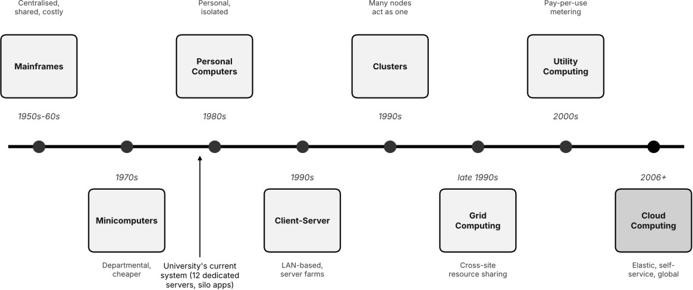
Figure 1: Evolution of computing infrastructure from mainframes to cloud, with the university's current position marked
Table 3: How each stage solved a limitation of the previous one

Stage | Key idea | Limitation it solved | New limitation
Mainframes (1950s-60s) | Central shared machine with terminals | Computing was unavailable to most users | Very costly, single point of failure
Minicomputers  (1970s) | Smaller departmental  machines | Mainframe cost and access | Islands of computing, hard to  share
PCs (1980s) | Personal, low-cost computing | Dependence on central machines | Isolated data, weak sharing and control
Client-server (1990s) | Clients call shared servers over a LAN | Isolation of PCs | One server per application, poor utilisation
Clusters (1990s) | Many nodes act as one system | Single-server capacity and  failure | Fixed, locally owned capacity
Grid (late 1990s) | Pooling of resources across sites | Idle capacity at one site | Complex middleware, limited commercial model
Utility (2000s) | Metered pay-per-use computing | Up-front purchase of capacity | Needed flexible provisioning
Cloud (2006+) | Virtualised, elastic, self-  service, API-driven | Rigid capacity and slow  provisioning | Lock-in, security and cost  governance

Hardware evolution that enabled the cloud
Table 4: Hardware advances and their role in enabling cloud computing

Advance | Contribution to cloud
Multi-core processors with hardware virtualization support (Intel VT-x, AMD-V) | Many VMs run on one host with low overhead; made server consolidation practical.
Commodity x86 servers | Cheap, replaceable building blocks; failure handled in software  rather than expensive hardware.
High-capacity disks, SSDs and distributed storage | Cheap, scalable, replicated object and block storage.
High-speed networking (Gigabit to 100 Gb Ethernet) | Fast links between racks and regions enable distributed services and remote delivery.
Warehouse-scale data centres | Economies of scale, shared power and cooling, automated operations.

University's current stage. The current system corresponds to the client-server stage with dedicated servers (one application per physical server, on-premise, no sharing). Reasons: fixed per-application capacity (15% average vs 95% peak), monolithic software, no virtualization or elasticity, no metering, and no DR. It has not reached the cluster, utility or cloud stage, which is why migration is justified.

Task 3 - Analyse Internet Software Evolution
Software moved from locally installed programs to services delivered over the internet. The evolution runs: static web pages (HTML documents, read-only), dynamic web (server-side scripts and databases generate pages), Web 2.0 (user-generated content and rich interaction through AJAX), SOA (applications built from reusable services with defined interfaces), mashups (combining several service APIs into one application), and cloud-hosted applications (software and platforms delivered on demand).
Role of enabling technologies. The browser is a universal thin client, so nothing is installed on user machines. HTTP/HTTPS is the common, firewall-friendly transport. AJAX lets a page fetch data in the background without a full reload, giving desktop-like responsiveness. APIs (REST and SOAP) expose functions as services, so a mobile app, a partner college or another service can reuse them.
Table 5: Desktop vs client-server vs web-delivered software

Aspect | Desktop software | Client-server software | Web-delivered software
Installation and updates | On every machine, manual | Client install, server update | None on client; central updates
Access | One device | Within the LAN/VPN | Any device with a browser or  app
Scalability | Limited to the machine | Limited to server capacity | Elastic through cloud back end
Integration | Poor, file-based | Proprietary protocols | Open APIs over HTTP
Maintenance cost | High (many endpoints) | Medium | Low and centralised

Effect on the university's applications. The monolithic applications should be separated into a thin web or mobile front end, an API layer and back-end services with a managed database. Stateless services enable auto-scaling; APIs enable the mobile app and partner colleges; and commodity functions (email, LMS, library) can be replaced by web-delivered SaaS rather than maintained in-house.

Task 4 - Apply Server Virtualization

Hypervisor and virtualization types
A hypervisor (virtual machine monitor) sits between hardware and guest operating systems. It partitions CPU, memory, storage and network into virtual machines, schedules them on physical resources, and isolates them from each other. A Type-1 (bare-metal) hypervisor runs directly on hardware (VMware ESXi, Microsoft Hyper-V, KVM, Xen) and is used in production data centres. A Type-2 (hosted) hypervisor runs as an application on a host OS (VirtualBox, VMware Workstation) and suits development and testing.
Table 6: Virtualization approaches compared

Approach | How it works | Overhead and isolation | Typical use
Full virtualization | Hypervisor emulates hardware; unmodified guest OS | Moderate overhead, strong isolation | Legacy applications on VMs
Para-virtualization | Guest OS is modified to call the  hypervisor (hypercalls) | Lower overhead, needs guest  support | Xen-style Linux guests
OS-level (containers) | Share the host kernel; isolated by namespaces and cgroups | Very low overhead, weaker isolation than VMs | Microservices, APIs (Docker)
Hardware-assisted | CPU extensions (VT-x, AMD-V) run guests natively | Near-native speed, enables modern full virtualization | Foundation of all modern hypervisors

What runs as a VM and what as a container
Table 7: Placement of university workloads

Application | Placement | Reason
Legacy monolithic SIS (phase 1) | VM | Needs its own OS and configuration; lift-and-shift with  minimal change.
Exam Portal | Container | Stateless web tier; scales out within seconds at exam peaks.

REST API services (results, fees, library) | Containers | Small, stateless, frequently updated and replicated.
Database servers (if self-managed) | VM | Stable, stateful workloads needing storage guarantees  (later replaced by DBaaS).
LMS, Library, Email | Vendor-managed (SaaS) | Commodity applications; the vendor handles the virtualization.

Consolidation calculation
Assumptions: each existing physical server has capacity 1 server-equivalent (SE); average utilisation 15%; target host utilisation 70%; each new host has the same capacity as one old server (conservative, since modern hosts are usually larger); hypervisor overhead 10%; peak utilisation 95%; HA reserve of one extra host (N+1).
Table 8: Worked consolidation calculation

Step | Working | Result
1. Average load | 12 servers x 15% | 1.80 SE
2. Add hypervisor overhead | 1.80 x 1.10 | 1.98 SE
3. Hosts for average load | 1.98 / 0.70 = 2.83 | 3 hosts
4. Add N+1 for HA and live migration | 3 + 1 | 4 hosts
5. Reduction in hardware | (12 - 4) / 12 | 66.7% fewer servers
6. Peak load (admissions/exams) | 12 x 95% x 1.10 = 12.54 SE | 12.54 SE
7. Hosts needed at peak at 70% target | 12.54 / 0.70 = 17.9 | about 18 hosts

Interpretation and peak-load caution. Four hosts handle everyday load comfortably (about 50% average host utilisation including the spare), but the same cluster cannot absorb the peak, which needs about 18 host-equivalents. Buying 18 hosts to cover a few weeks a year would recreate today's waste. The design therefore keeps a small baseline and bursts to public-cloud capacity through auto-scaling for the peak weeks. These numbers are estimates and must be confirmed by load testing.

Benefits and risks
    - Live migration moves a running VM between hosts without downtime, so hosts can be patched or a failing host drained. Snapshots capture VM state for rollback before upgrades and quick recovery.
Over-commitment allocates more virtual CPU/memory than physical (safe at 15% average utilisation) to raise utilisation.
    - Risks: noisy neighbour (one VM starving others; mitigate with resource limits and reservations), hypervisor failure (a single host failure affects every VM on it; mitigate with clustering, N+1 and HA restart), and security isolation (VM escape or container kernel sharing; mitigate with patching, hardened images, network segmentation and separating sensitive workloads).

Task 5 - Apply Web Services
A web service is a software function exposed over a network using standard protocols so that different systems can call it regardless of platform. In SOA, applications are assembled from loosely coupled services with published contracts; in the cloud, web services are how front ends, mobile apps, partners and other services consume university functions.
Table 9: SOAP, WSDL, UDDI and REST compared

Item | Description | Notes
SOAP | XML messaging protocol with a strict envelope | Supports WS-Security and transactions; verbose and heavier.
WSDL | XML description of a SOAP service: operations, messages, endpoints | Machine-readable contract that lets tools generate client code.
UDDI | Registry for publishing and discovering services | Rarely used today; replaced by API catalogues and gateways.

REST | Architectural style using HTTP methods (GET, POST, PUT, DELETE) on resource URLs | Lightweight, typically JSON (or XML), stateless and cache-friendly; ideal for mobile and web.

University functions exposed as web services
Table 10: Defined web services

Function | Endpoint and method | Style and justification
Result lookup | GET /api/v1/results/{regNo} | REST. Read-only, cacheable, used by the mobile  app and colleges; JSON is light.
Fee payment | POST /api/v1/fees/pay | REST at the public edge for the app and colleges; SOAP only behind it if a partner bank mandates  WS-Security.
Library search | GET /api/v1/library/books?q={text} | REST. Simple query, cacheable, high volume.

Result lookup - request and response
GET /api/v1/results/21CS1001 HTTP/1.1 Host: api.university.example Authorization: Bearer <token>

HTTP/1.1 200 OK
Content-Type: application/json
{"regNo":"21CS1001","name":"Student A","semester":5,"gpa":8.6,"status":"PASS"}

Fee payment - request and response
POST /api/v1/fees/pay HTTP/1.1 Content-Type: application/json
{"regNo":"21CS1001","amount":45000}

HTTP/1.1 201 Created
{"receiptId":"RCPT-0001","regNo":"21CS1001","amount":45000,"status":"SUCCESS"}

Library search - request and response
GET /api/v1/library/books?q=cloud HTTP/1.1

HTTP/1.1 200 OK
{"query":"cloud","count":1,"books":[{"id":1,"title":"Cloud Computing: Concepts, Technology and Architecture"}]}

SOAP alternative (illustrative). If the bank requires SOAP for fee reconciliation, the same function would use an XML envelope:
<soap:Envelope xmlns:soap="http://www.w3.org/2003/05/soap-envelope">
<soap:Body><PayFee><regNo>21CS1001</regNo><amount>45000</amount></PayFee></soap:Body>
</soap:Envelope>

Overall justification. REST is chosen for all three public services because mobile apps and 40 colleges need lightweight, cacheable, easily secured JSON calls. SOAP is kept only as an adapter where a formal contract, WS-Security or a legacy partner requires it.

Task 6 - Analyse the Service Models: IaaS, PaaS and SaaS
IaaS provides virtualised infrastructure (compute, storage, network); the customer manages the OS and everything above. PaaS provides a managed runtime platform; the customer manages only the application and its data. SaaS delivers a complete application; the customer only configures and uses it.
Table 11: Who manages each layer

Layer | On-premise | IaaS | PaaS | SaaS
Application | Customer | Customer | Customer | Provider

Data | Customer | Customer | Customer | Provider (customer owns the data)
Runtime / middleware | Customer | Customer | Provider | Provider
Operating system | Customer | Customer | Provider | Provider
Virtualization | Customer | Provider | Provider | Provider
Servers, storage, network, data centre | Customer | Provider | Provider | Provider

Table 12: Categorisation of the five university applications

Application | Final model | Stage-1 (migration) model | Reasoning
Student Information System | PaaS | IaaS (lift-and-shift VM) | Custom business logic must be kept, but patching OS  and runtime is wasteful; PaaS gives auto-scaling and a managed database.
Learning Management System | SaaS | SaaS | Commodity function (a hosted Moodle- or Canvas-type service); the vendor handles scale for exam and  assignment peaks.
Library System | SaaS | SaaS | Low customisation and modest load; a hosted library  service removes server maintenance entirely.
Exam Portal | PaaS | IaaS or containers | Highly bursty and unique to the university; needs fast scale-out and control of the application, not of the OS.
Email | SaaS | SaaS | Email is a standard utility with strong SLAs; self-hosting offers no advantage.

Decision reasoning. The rule applied is: use the highest-level model that still meets the functional need, because each step up the stack removes management effort. Email, LMS and Library are commodities, so SaaS. The SIS and Exam Portal contain university-specific logic, so PaaS keeps control of the application while the provider runs the platform. IaaS is kept only as a transitional step for legacy components and as the foundation under PaaS.
Table 13: Comparison of the service models

Criterion | IaaS | PaaS | SaaS
Control | Highest (OS and above) | Medium (application and data) | Lowest (configuration only)
Cost | Pay per resource; staff cost  remains | Moderate, includes platform  management | Predictable per-user  subscription
Scalability | Manual or scripted | Automatic by platform | Handled by vendor
Maintenance effort | High | Medium | Lowest
Vendor lock-in | Low-medium | Medium-high (platform APIs) | Highest (data and workflow)
Provider example | AWS EC2, Azure Virtual  Machines | Azure App Service, Google App  Engine | Microsoft 365, Google  Workspace

Task 7 - Examine XaaS
XaaS (Anything-as-a-Service) generalises the service model: any IT capability can be consumed on demand, as a metered subscription, from a provider. It extends beyond IaaS, PaaS and SaaS to databases, security, backup, functions, desktops and more.
Table 14: XaaS variants and their relevance

Variant | What it provides | University relevance
DBaaS | Managed database with backup, patching,  replication and scaling | SIS and fee records; removes database  administration, multi-AZ built in.
DRaaS | Replicated environment and orchestrated  failover in another region | Closes the university's biggest gap: no disaster  recovery site.
FaaS (serverless) | Event-driven functions billed per execution | Result lookups, receipts and notifications that spike during result publication.
MBaaS / BaaS | Ready-made back end for mobile apps  (auth, push, storage) | Speeds up the Day-4 mobile app.

Security-as-a-Service | Managed WAF, identity, threat detection | Protects public APIs exposed to colleges.
DaaS | Hosted virtual desktops | Computer labs on any device, with licence control.

Two selected offerings. (1) DBaaS: student records and fee transactions are the university's most valuable data and the hardest workload to run reliably; DBaaS gives automated backup, patching, multi-zone replication and point-in-time recovery without a dedicated DBA team, and scales read capacity for result days. (2) DRaaS: the university currently has no DR site; building one would double CapEx, whereas DRaaS gives an off-site replica for a small monthly cost, with a stated recovery time and recovery point objective, and supports the 99.9% target.
Risks of over-reliance on many 'as-a-Service' providers. Lock-in grows with each provider and moving away becomes costly; an outage at one provider can cascade through dependent services; integration and identity management across many vendors add complexity; costs can sprawl without monitoring; each provider adds a data-protection and compliance obligation; and SLAs differ and may not add up to the availability the university needs. Mitigation: open standards and portable formats, exit plans, a central cost dashboard, a single identity provider, and review of every provider's SLA.

Task 8 - Design the Cloud Solution Architecture
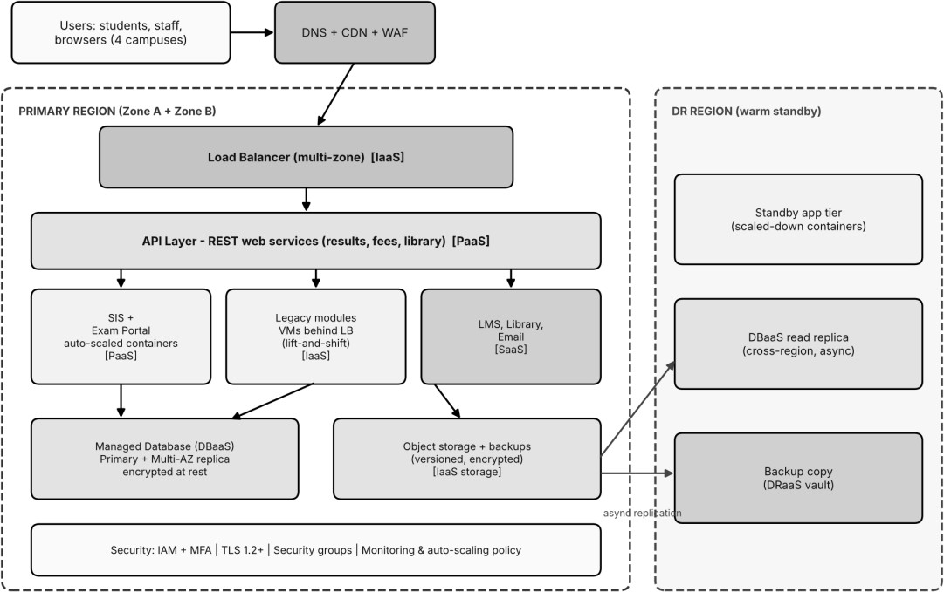

Figure 2: Proposed hybrid cloud architecture for the university (primary region with two zones, and DR region)
Table 15: Component, deployment model, service model and justification

Component | Deployment / service model | Justification
DNS, CDN and WAF | Public cloud / XaaS | Fast global delivery, caching of static pages, protection against attacks during public result days.
Load balancer (multi-zone) | Public / IaaS | Distributes traffic and removes unhealthy nodes, enabling zone failover.
API layer (REST services) | Public / PaaS | Single controlled entry for the app and colleges; version-  controlled; scales independently.
SIS and Exam Portal (containers) | Public / PaaS | Auto-scaling handles admissions and exam peaks; no OS patching.
Legacy modules (VMs) | Public / IaaS | Temporary lift-and-shift so migration starts without rewriting everything.

LMS, Library, Email | Public / SaaS | Commodity services, vendor SLA, no servers to run.
Managed database (primary and replica) | Public / DBaaS | Reliability of student and fee data; automated backup and multi-AZ failover.
Object storage and backups | Public / IaaS storage | Cheap, durable, versioned storage for documents and  backups.
DR region | Public / DRaaS | Warm standby with replicated data; recovery without a second data centre.
Identity and campus network link | Private / hybrid | Keeps directory and sensitive data under university control through VPN.

Elasticity. Auto-scaling policies add container instances when average CPU exceeds 60% or when request queue length grows, and remove them when load falls. Before known events (admissions, results, exams) a scheduled rule pre-warms capacity so scaling does not lag the first surge. Baseline capacity stays small (the 4-host equivalent from Task 4), with burst capacity billed only while used.
Security and availability. Role-based access control and multi-factor authentication for staff; encryption in transit (TLS) and at rest (provider-managed keys); security groups and network segmentation between tiers; WAF in front of the API; automated daily backups with versioning and a tested restore; multi-zone deployment for the web, application and database tiers; cross-region replication to the DR region; and central logging with alerting.

Task 9 - Hands-on Implementation and Documentation
Proof-of-concept scope. A containerised Flask REST API serving the three university functions from Task 5, run locally with Docker (virtualization) and then deployed to a free-tier PaaS (for example Azure App Service, Google Cloud Run or Render). The code below was run and tested while preparing this report; the screenshots in this section must be taken on your own machine or cloud account and pasted into the marked boxes.

Environment
    - Python 3.x, Flask, Docker Desktop (or Docker Engine), curl or Postman, a free-tier cloud account. Project folder: uni-api/ containing app.py, requirements.txt and Dockerfile.

Source code
app.py (Flask REST API):
from flask import Flask, jsonify, request

app = Flask( name )

# Demo data (stands in for the managed database in the real design) RESULTS = {
"21CS1001": {"name": "Student A", "semester": 5, "gpa": 8.6, "status": "PASS"},
"21CS1002": {"name": "Student B", "semester": 5, "gpa": 7.9, "status": "PASS"},
}
BOOKS = [
{"id": 1, "title": "Cloud Computing: Concepts, Technology and Architecture"},
{"id": 2, "title": "Distributed Systems: Principles and Paradigms"},
{"id": 3, "title": "Computer Networks"},
]

@app.route("/health") def health():
return jsonify(status="UP"), 200

@app.route("/api/v1/results/<reg_no>", methods=["GET"]) def get_result(reg_no):

record = RESULTS.get(reg_no)
if record is None:
return jsonify(error="Result not found", regNo=reg_no), 404
return jsonify(regNo=reg_no, **record), 200

@app.route("/api/v1/fees/pay", methods=["POST"]) def pay_fee():
data = request.get_json(silent=True) or {}
if not data.get("regNo") or not data.get("amount"):
return jsonify(error="regNo and amount are required"), 400
return jsonify(receiptId="RCPT-0001", regNo=data["regNo"],
amount=data["amount"], status="SUCCESS"), 201

@app.route("/api/v1/library/books", methods=["GET"]) def search_books():
q = request.args.get("q", "").lower()
found = [b for b in BOOKS if q in b["title"].lower()]
return jsonify(query=q, count=len(found), books=found), 200

if name == " main ":
app.run(host="0.0.0.0", port=8000)

requirements.txt:
flask==3.0.3 gunicorn==22.0.0

Dockerfile:
FROM python:3.12-slim WORKDIR /app
COPY requirements.txt .
RUN pip install --no-cache-dir -r requirements.txt COPY app.py .
EXPOSE 8000
CMD ["gunicorn", "-b", "0.0.0.0:8000", "app:app"]

Build, run and test steps
- Build the image: docker build -t uni-api .
- Run the container: docker run -d -p 8000:8000 --name uni-api uni-api
- Confirm it is running: docker ps
- Test success: curl -i http://localhost:8000/api/v1/results/21CS1001 - expected HTTP 200
and the JSON in Task 5.
- Test failure: curl -i http://localhost:8000/api/v1/results/99XX0000 - expected HTTP 404
with {"error":"Result not found","regNo":"99XX0000"}.
- Test POST: curl -X POST -H "Content-Type: application/json" -d
'{"regNo":"21CS1001","amount":45000}' http://localhost:8000/api/v1/fees/pay - expected HTTP 201.
- PaaS deployment: push the folder to GitHub, create a new web service on the chosen free-tier PaaS from the repository (or from the Docker image), set the start command to the Dockerfile CMD, wait for the deployment to turn healthy, then repeat steps 4 and 5 against the public URL.

Output observed during code testing (local run):
HTTP/1.1 200 OK
{"gpa":8.6,"name":"Student A","regNo":"21CS1001","semester":5,"status":"PASS"}

HTTP/1.1 404 NOT FOUND
{"error":"Result not found","regNo":"99XX0000"}

{"amount":45000,"receiptId":"RCPT-0001","regNo":"21CS1001","status":"SUCCESS"}

Required screenshots (insert your own)
[ INSERT YOUR OWN SCREENSHOT HERE: docker build and docker ps showing the running uni-api container ]
Figure 3: docker build and docker ps showing the running uni-api container
[ INSERT YOUR OWN SCREENSHOT HERE: curl or Postman: HTTP 200 JSON response for the result lookup ]
Figure 4: curl or Postman: HTTP 200 JSON response for the result lookup
[ INSERT YOUR OWN SCREENSHOT HERE: curl or Postman: HTTP 404 failure case ]
Figure 5: curl or Postman: HTTP 404 failure case
[ INSERT YOUR OWN SCREENSHOT HERE: PaaS dashboard showing the deployed service and its public URL working ]
Figure 6: PaaS dashboard showing the deployed service and its public URL working
Issues and fixes to record (write your actual experience): for example port conflicts (change -p 8001:8000), Docker not running, missing requirements.txt at build time, or the PaaS expecting a different start command or port. Note how each was resolved.

Task 10 - Evaluate and Recommend the Final Solution
Table 16: Comparison of the three options

Criterion | On-premise (refresh) | IaaS-based | PaaS/SaaS-based (chosen)
Cost model | High CapEx, fixed OpEx | OpEx, pay per resource | OpEx, subscription and usage
Scalability | Fixed; fails at peaks | Good but manual or  scripted | Automatic and elastic
Availability | Single site, no DR | Multi-zone possible, you build it | Multi-zone and DR built in
Security | Full control, full  responsibility | Shared responsibility; OS is  yours | Provider secures platform; you  secure app and data
Effort / staff | Highest (3 staff) | High (2 staff) | Lowest (1.5 staff)

Table 17: Three-year cost comparison (Rs lakh, stated assumptions)
Item | On-premise | IaaS-based | PaaS/SaaS-based
One-time (CapEx / migration) | 90 | 10 | 14
Annual running cost | 35 | 44 | 35
Three-year running cost | 105 | 132 | 105
Three-year total | 195 | 142 | 119
Disaster recovery included | No | Yes (in annual cost) | Yes (in annual cost)

Assumptions. On-premise: 12 replacement servers at Rs 6 lakh each (72) plus storage, network and UPS
(18) = 90 CapEx; annual power and cooling 8, maintenance contracts 9, three administrators at 6 each (18)
= 35. IaaS: annual compute 14, peak burst 6, storage and backup 4, network 3, DR replica 5, two
administrators 12 = 44; migration 10. PaaS/SaaS: SaaS subscriptions 12, PaaS and database 11, backup and DR 3, 1.5 staff 9 = 35; migration and re-engineering 14. These are planning estimates and must be validated with provider calculators and quotations before commitment.

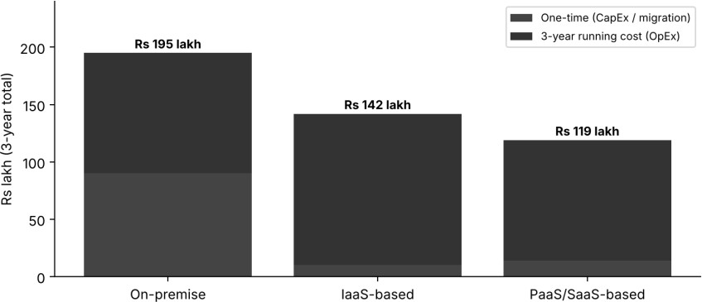
Figure 7: Three-year total cost by option (Rs lakh)
Table 18: Main risks and mitigation

Risk | Mitigation
Vendor lock-in | Use containers and open APIs, keep data in portable formats, document an exit plan, avoid proprietary services for core logic.
Data privacy and residency | Encrypt data at rest and in transit, choose an in-country region, sign data-processing agreements, role-based access, audit logs.
Downtime | Multi-zone deployment, DRaaS, health checks, tested backups and runbooks, SLA review.
Skills gap | Train staff on cloud fundamentals and DevOps, use managed services, engage a partner for the first migration.

Final recommendation. Adopt the hybrid, PaaS/SaaS-first solution with IaaS only as a transitional step. It has the lowest three-year cost (119 vs 195 and 142), is the only option that handles the exam peaks automatically, includes DR, and cuts operations effort to 1.5 staff. It follows from the analysis: consolidation shows that fixed servers cannot cover peaks (Task 4), APIs make the services reusable (Task 5), and the service-model mapping removes management of commodity applications (Task 6).
Table 19: Migration roadmap

Phase | Applications and activity | Reason for order
1 (months 1-2) | Email to SaaS; set up identity, network link, monitoring and backup foundation | Lowest risk, no custom code, quick visible win, builds team skills.
2 (months 3-4) | LMS and Library to SaaS; data migration with parallel run | Commodity services; frees servers early.
3 (months 5-7) | Exam Portal to PaaS containers with auto-scaling; load test | Highest benefit from elasticity; moved before the next exam cycle.
4 (months 8-10) | SIS lift-and-shift to VM, then refactor to PaaS with DBaaS and the API layer; enable DR | Most critical and complex application moved last, with experience gained.
5 (month 11-12) | Decommission old servers, review costs and SLAs | Realises the savings.

Task 11 - Day-4 Design Challenge: Re-evaluate and Adapt the Design
Changed requirement: mobile app launch; student-record and fee-payment services opened to 40 affiliated colleges; expected load 10 times the current peak; 99.9% availability; limited operating budget. Decision: MODIFY the original solution (keep the hybrid, PaaS/SaaS-first philosophy and containers, but redesign the API, compute, data and resilience layers).

Impact analysis
    - What changed: users grow from 27,000 internal users to many more through colleges and mobile, access is continuous (app and payments), and external organisations now depend on the services.
    - Assumptions affected: load (11.4 SE peak becomes about 114 SE); users (new tenants and devices);
availability (best effort becomes 99.9%, i.e. about 8.76 hours per year); cost (must scale sub-linearly with load).

    - Why web services and APIs become critical: the mobile app and colleges can only use the system through APIs, so API security, versioning, throttling and uptime become the real product.
    - Multi-tenant security and isolation: every college must see only its own data. This needs tenant identity in every token, row-level or schema-level separation in the database, per-tenant rate limits and quotas, encryption, audit logs, and no shared secrets.

Evaluation of the original design
Table 20: Original design vs new requirements

Question | Finding
Can service models and virtualization handle 10x load? | PaaS containers and SaaS scale well, but the original baseline of about 4 hosts and a manually managed IaaS portion would be overwhelmed; a plain scale-up needs about 179 host-equivalents at 70% target, which is not affordable if  provisioned fixed.
Are auto-scaling and one region enough for 99.9%? | No. Auto-scaling covers load, not failure. With a single zone the composite availability is about 98.9% (0.999 x 0.995 x 0.995), roughly 96 hours of  downtime per year, far above the allowed 8.76.
Is cost acceptable? | Scaling the original design linearly (always-on peak capacity) costs about Rs  117 lakh per year, which breaks the budget.
Would another model or XaaS help? | Yes: API gateway, serverless (FaaS) for spiky functions, managed caching and queues, DRaaS and security services reduce compute needed and improve availability.

Adaptation / redesign
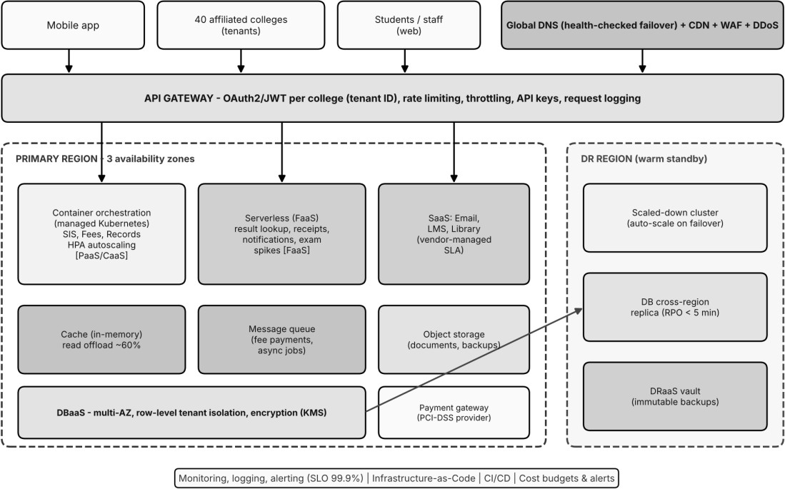

Figure 8: Revised Day-4 architecture with API gateway, container orchestration, serverless, three zones and DR region
    - Service-model mix: the PaaS/SaaS core stays; the SIS, fee and record services run on managed container orchestration (CaaS); bursty read functions (result lookup, receipts, notifications) move to FaaS; an API gateway and managed cache and queue are added; DBaaS becomes multi-AZ with a cross-region replica; DRaaS and Security-as-a-Service (WAF/DDoS) are added; email, LMS and
library remain SaaS.
    - Virtualization approach: most compute moves from VMs to containers with horizontal pod auto-scaling; VMs remain only for legacy modules still being refactored.

    - Why not a full redesign: the principles (managed services, elasticity, APIs) are already correct; replacing everything would add migration effort and risk for no extra benefit.

Evidence-based defence
Capacity. Current peak is 12 x 0.95 = 11.4 SE; 10x gives 114 SE; adding 10% hypervisor overhead gives 125.4 SE; at 70% target this is 179 host-equivalents if all load hit the origin. Assuming caching, CDN and serverless offload about 50% of origin compute, the need is about 90 node-equivalents at peak, versus a baseline of about 12 nodes. If the peak lasts 4 weeks a year, the average is (12 x 48 + 90 x 4) / 52 = 18 nodes, which is 80% below provisioning 90 nodes permanently. (Assumes one modern 8-vCPU node is roughly one legacy server; to be confirmed by load testing.)
Availability. In the revised design the serial chain is DNS/CDN 99.99%, load balancing 99.99%, application tier in two or more zones (each zone 99.5%, so 1 - 0.005^2 = 99.9975%), and multi-AZ DBaaS 99.95%. The product is 0.9999 x 0.9999 x 0.999975 x 0.9995 = 99.93%, about 6.3 hours of downtime per year, inside the 8.76-hour budget. The cross-region DR replica covers a full region failure with manual or automated failover.
Table 21: Annual cost: original, naive scale-up and revised design (Rs lakh, assumptions)

Design | Annual cost | Notes
Original (PaaS/SaaS) at old load | 35 | Task 10 estimate; cannot meet new load or availability.
Naive scale-up (always-on peak  capacity) | 117 | 90 nodes always on 70.2, database 15, storage and DR 8,  SaaS 12, staff 12.
Revised design | 66 | Containers 11, FaaS 3, gateway/WAF/CDN 6, DBaaS 11, cache and queue 4, storage and DR 7, SaaS 12, monitoring 3, staff 9.

The revised design costs about 44% less than naive scaling (66 vs 117) while meeting 10x load and 99.9%. Three-year cost is about 66 x 3 + 12 one-time re-engineering = Rs 210 lakh, against about Rs 359 lakh for naive scale-up (117 x 3 + 8). As an optional budget control, a chargeback of about Rs 0.5 lakh per college per year (Rs 20 lakh for 40 colleges) could offset the extra cost; this is a proposal, not a given.
Security and multi-tenancy. OAuth2/JWT with tenant ID per college at the gateway, row-level security in the database keyed by tenant, per-tenant quotas, encryption with managed keys, a PCI-DSS-compliant payment provider so card data never touches university servers, audit logging, and regular penetration tests.
Trade-offs. Vendor lock-in rises with gateway, FaaS and DBaaS, mitigated by containers, open API standards and an exit plan. Complexity rises with orchestration and many services, mitigated by managed offerings, infrastructure-as-code and training. Migration effort is moderate (about 12 lakh), because the PaaS/SaaS core is retained. Overall, the modified design gives the best balance of scalability, availability and cost, and it should be confirmed through a load test at 10x and a failover drill before go-live.
Conclusion. The university should adopt the hybrid, PaaS/SaaS-first design in phases, modified on Day 4 with an API gateway, container orchestration, serverless components, multi-zone deployment and DR as a service.

